

D-Link IP Surveillance SDK (CGI/API) V2.2

In this document, you can find all D-Link camera SDK/API/CGI support documents.
There are three series for current D-Link IP surveillance products.
- NIPCA series
- MJPEG series
- VCA series

NIPCA series
<Support models>
DCS-1100(L), DCS-1130(L), DCS-2102, DCS-2103, DCS-2121, DCS-2130, DCS-2132L , DCS-2136L, DCS-2210, DCS-2230, DCS-2310L, DCS-2332L, DCS-3010, DCS-3112, DCS-3410, DCS-3411, DCS-3430, DCS-3710, DCS-3710 B1, DCS-3715, DCS-3716, DCS-5211L, DCS-5222L, DCS-5230L, DCS-5605, DCS-5635, DCS-6010L, DCS-6112(V), DCS-6113(V), DCS-6210, DCS-6314, DCS-6410, DCS-6510, DCS-6511, DCS-6513, DCS-6616, DCS-681x B1, DCS-6915, DCS-7010L, DCS-7110, DCS-7410, DCS-7413, DCS-7510, DCS-7513, DVS-310-1, DVS-V310-4, DCS-940L, DCS-942L
NO. | Check Item | Overview | Attachment file
1 | NetIPCamAPI-1.9.5 | Network IP Camera Access Application Programming Interface (NIPCA-API) is a HTTP-based API for the networks IP surveillance products.  Users can write program easily by calling this API to access all functionalities provided by our IP cameras including: configuration, multimedia streaming data and the control facilities.  Except Streaming, the other groups of API use the same format in transporting HTTP-based message.  P.S.: As for the Streaming API, the output format of streaming API depends on different IP camera model. Here we only provide a general entry point to let the IP camera outputting streaming via a permanent HTTP connection. | 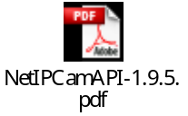
2 | DCS-1100(L)_1130(L) support table | Firmware version: 1.02 | 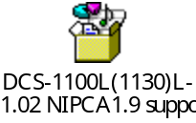
3 | DCS-2121/2102 for NIPCA support table | Firmware version: 1.0.4 | 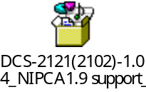
4 | DCS-2103 for NIPCA support table | Firmware version: 0.05.00 | 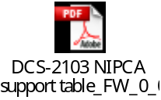
5 | DCS-2130 for NIPCA support table | Firmware version: 0.00.00 | 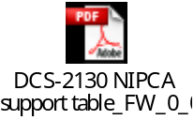
6 | DCS-2132L for NIPCA support table | Firmware version: 0.01.02 | 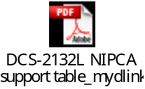
7 | DCS-2136L for NIPCA support table | Firmware version: 1.00 | 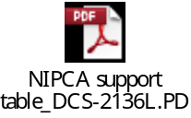
8 | DCS-2210 for NIPCA support table | Firmware version: 1.00 | 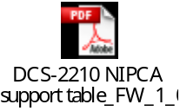
9 | DCS-2230 for NIPCA support table | Firmware version: 0.01.00 | 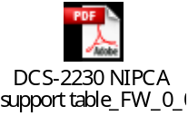
10 | DCS-2310L for NIPCA support table | Firmware version: 0.01.02 | 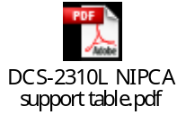
11 | DCS-2332L for NIPCA support table (as same as DCS-2132L) | Firmware version: 1.00 | 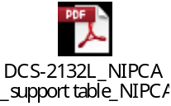
12 | DCS-3010 for NIPCA support table | Firmware version: 0.01.00 | 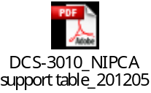
13 | DCS-3112 for NIPCA support table | Firmware version: 0.02.00 | 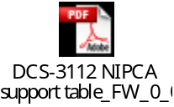
14 | DCS-3410 for NIPCA support table | Firmware version: 1.02 | 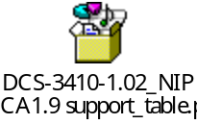
15 | DCS-3411_3430 support table | Firmware version: 1.00 | 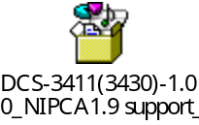
16 | DCS-3710 support table | Firmware version: 1.00 | 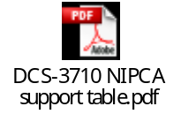
17 | DCS-3710 B1/DCS-3716 support table | Firmware version: 0.02.00 | 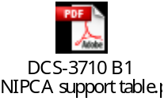
18 | DCS-3715 support table | Firmware version: 1.00 | 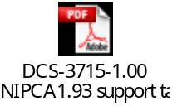
19 | DCS-5211L/5222L support table | Firmware version: 1.00,0904 | 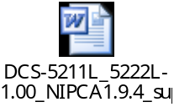
20 | DCS-5230L support table | Firmware version: 1.03, 5522 | 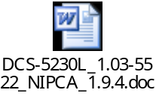
21 | DCS-5605 support table | Firmware version: 1.00 | 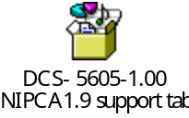
22 | DCS-5635 support table | Firmware version: 1.00 | 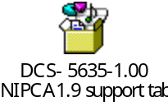
23 | DCS-6010L support table | Firmware version: 0.01.13 | 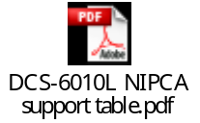
24 | DCS-6112(V)/6113(V) support table | Firmware version: 1.00 | 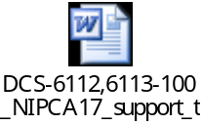
25 | DCS-6210 support table | Firmware version: 0.03.01 | 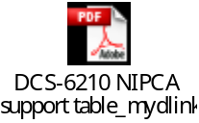
26 | DCS-6314 support table | Firmware version: 1.00 | As same as DCS-7513
27 | DCS-6410 support table | Firmware version: 1.00 | 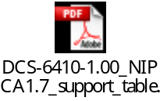
28 | DCS-6510 support table | Firmware version: 1.00 | 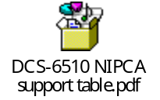
29 | DCS-6511 support table | Firmware version: 1.00 | 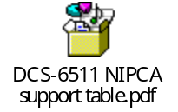
30 | DCS-6513 support table | Firmware version: 1.00 | As same as DCS-7513
31 | DCS-6616 support table | Firmware version: 1.00.12 | 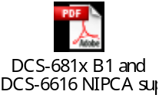
32 | DCS-681x B1 support table | Firmware version: 1.00.12 | 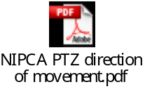
33 | DCS-6915 support table | Firmware version: 0.01.10 | 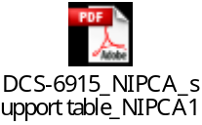
34 | DCS-7010L support table | Firmware version: 0.01.10 | 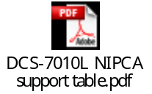
35 | DCS-7110 support table | Firmware version: 1.00 | 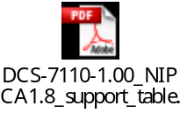
36 | DCS-7410 support table | Firmware version: 1.00 | 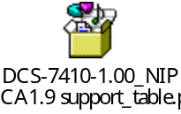
37 | DCS-7413 support table | Firmware version: 0.01.00 | 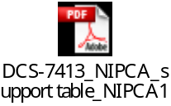
38 | DCS-7510 support table | Firmware version: 1.00 | 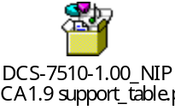
39 | DCS-7513 support table | Firmware version: 0.01.00 | 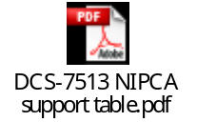
40 | DVS-310-1 support table | Firmware version: 1.00 | 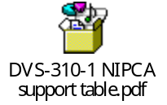
41 | DVS-V310-4 support table | Firmware version: 1.00 | 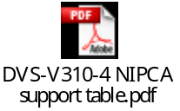
42 | DCS-940L Support Table | Firmware version: 1.00 | 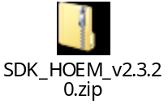
43 | DCS-942L Support Table | Firmware version: 1.00 | 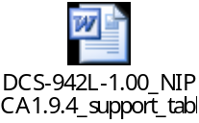
44 | LANDAP-1.41 | This protocol is mainly for setting device which is first time attached to the local area network and before it obtains a valid IP address.  Local Area Network Device Acquisition Protocol (LANDAP) is a UDP-based protocol for discovering and configuration devices on the local area network.  Such devices include IP camera, video servers or other service-based device. | 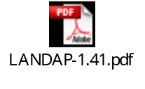

MJPEG Series
<Support model>
DCS-930(L) , DCS-931L, DCS-932(L), DCS-933L, DCS-5020L
NO. | Check Item | Overview | Attachment file
1 | DCS-930(L) CGI command | HTTP-based API for the networks IP surveillance products V1.25. | 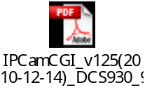
2 | DCS-931L CGI command | Firmware version: 1.00 | 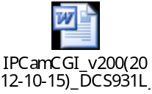
3 | DCS-932(L) CGI command | HTTP-based API for the networks IP surveillance products V1.25.
4 | DCS-933L CGI command | Firmware version: 1.00 | 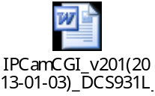
5 | DCS-5020L CGI command | Firmware version: 1.00

VCA Series
<Support model>
Same series share similar command list, only different is the functionality of each camera.
NO. | Check Item | Overview | Attachment file
1 | DCS-3420 CGI command | HTTP-based API | 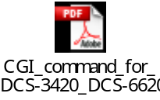(phased out)
2 | DCS-3420 video stream user data format | D-Link embedded some useful information in the video stream so that the developer can use them for advanced features in their software. The information includes digital input states, digital output states, motion detection, etc. This document describes the media data format used in DCS-3420, DCS-6620/G, and DCS-3220/G | 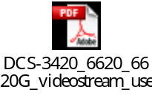(phased out)
3 | DCS-3420 Control Channel Signaling | This document describes signaling sequence and format of the control messages of control channel of D-Link DCS-3420, DCS-6620/G, and DCS-3220/G. Control channel exchange the capabilities of codec between server and client as well as the transport information that tells how media data can be delivered via network. All the control channels are based on HTTP protocol for signaling. | 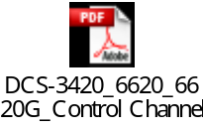(phased out)
4 | DCS-6111 CGI command | HTTP-based API | 

